Name: Alif Aiman Bin Basarulhisham

Quote: ”Oh yes, the past can hurt. But you can either run from it, or learn from it.” – Rafiki, from The Lion King

Bio: Born in 2001 and proudly from Kelantan, is a digital creative who enjoys bringing ideas to life through editing and 3D animation. When he’s not working on timelines or tweaking lighting in Blender or other editing programs, you’ll probably find him deep in a Valorant match, unwinding with anime, catching up on manhwas, or looping his favorite K-pop tracks. For Alif, creativity is all about expressing emotion, whether through visuals or the occasional clutch play.

Social Media: @liffyss (Instagram)

[@eunjibias6278](https://www.youtube.com/@eunjibias6278) (youtube)

Email: [alifaiman2710@gmail.com](mailto:alifaiman2710@gmail.com)



**Innocent**

1. I just drew a friend of mine by referencing on their character in GTA V



**Happiness**

1. Also drew another friend of mine referencing their character in GTA V



**Joyness**

1. The same thing



**Coolness**

1. Also the same thing hehhe

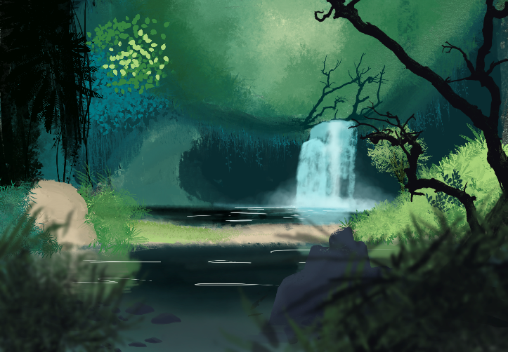

**Enchanted Waterfall**

1. I drew this landscape in class, which im quite particularly proud of. Quite enjoy making this tbh

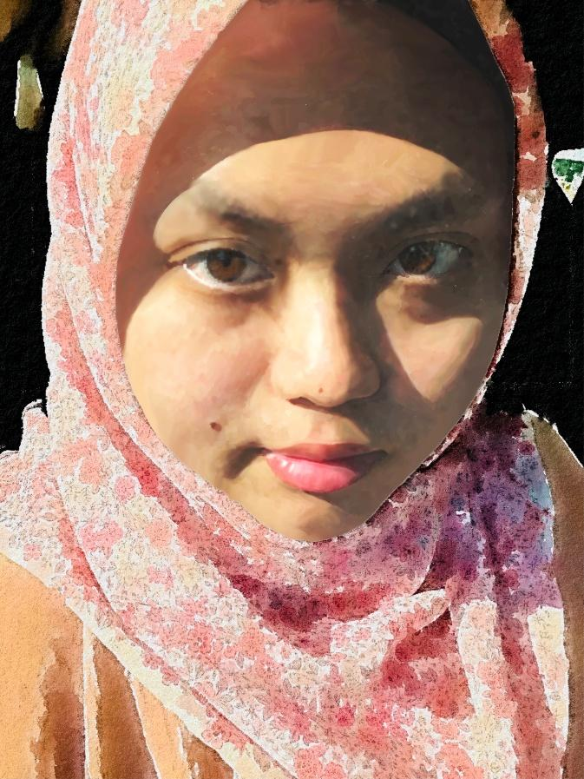

**Realism**

1. A painting of my partner, which I made in procreate. This took A LONG of time since this requires patience but the end result was amazing

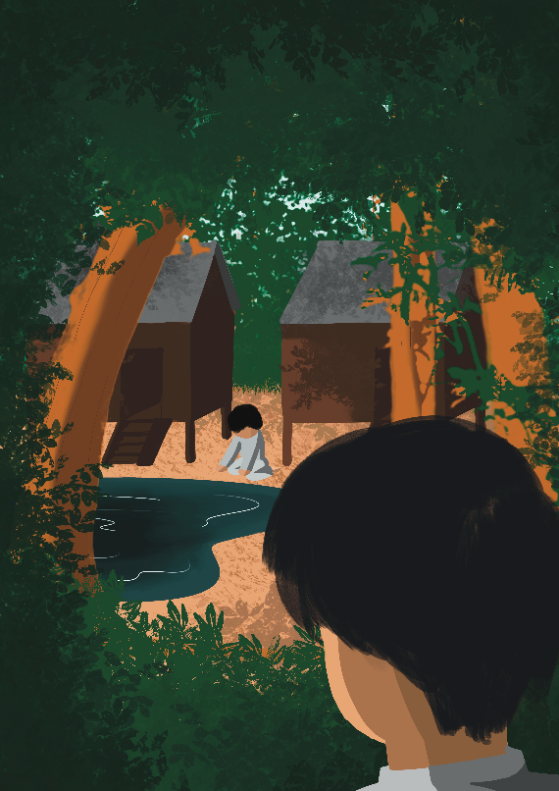

**Peaceful Village**

1. Also drew in class. The other side of bunian where they live in a beautiful village. The good side of bunian

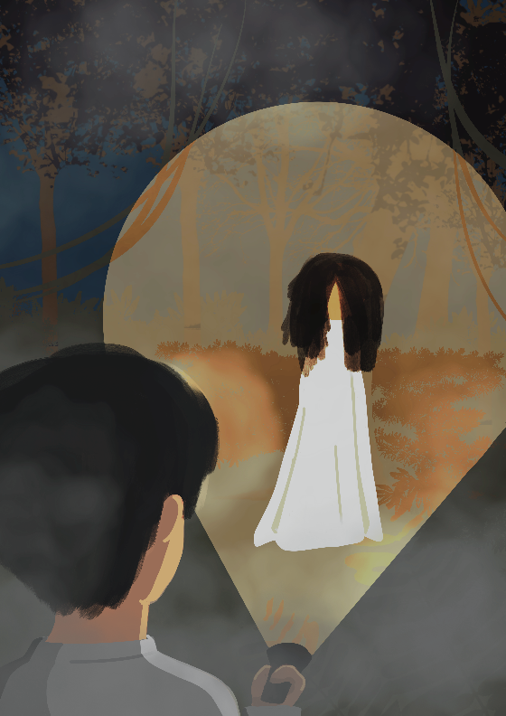

**Eerie Forest**

1. In the same class, but other side of bunian. This is the bad side

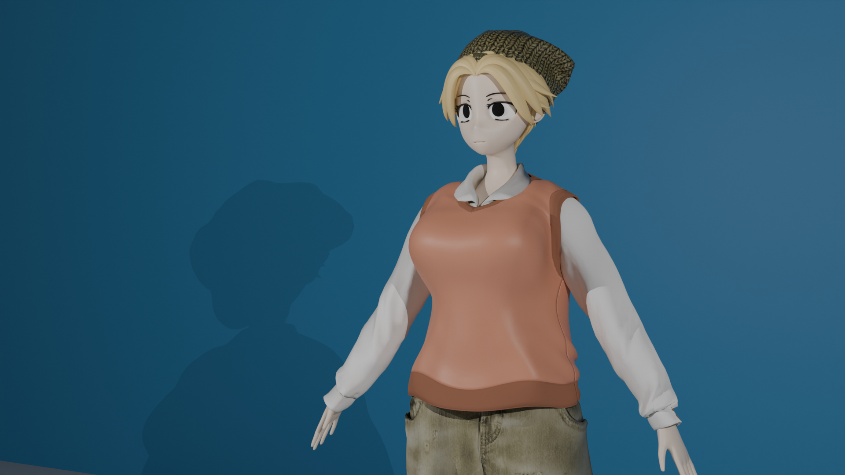

**Model Mesh**

1. i made this model during for my FYP project. it was a hassle but i think i did a pretty good job

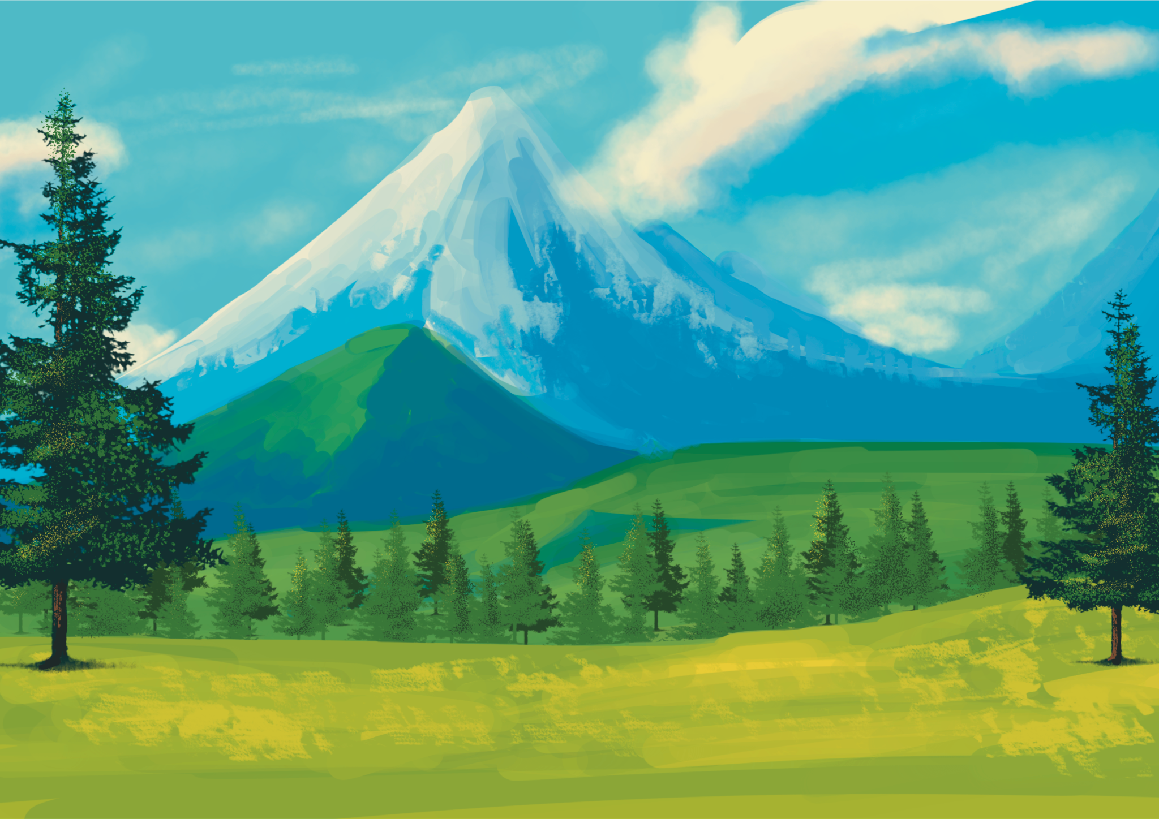

**Spring**

1. Drew this landscape for my artbook and it turned out pretty wel**l**